Goal: the goal is to get people to join the great barrier reefs orchestra. The goal is to increase traffic by a measurable amount.

Audience: anyone interested in orchestra, preferably a teenager or older. We will use a variety of colours and images to attract more people.

Success evaluation: We will measure how many people join and attend. The minimum attendance for this will be a 20% increase

The site: the theme we will go for is a blue background with coloured text and images will be implemented.

Content:

**Images and description**

* Home page
* Artists (musicians):
* Events
* Bulletin board
* Membership registration
* Feeder page
* Contact information
* sponsor details
* information about the organisation

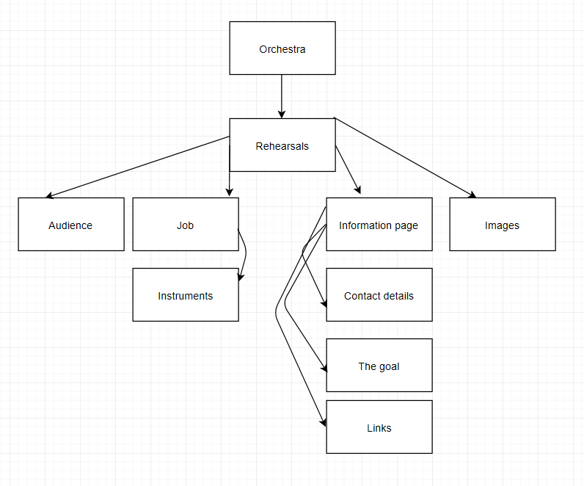

Design comps: blue background with various matching text, a dark background with bright text, either background with a different font